**Experiment No :- 04**

**Aim :** Write a program to demonstrate Single Inheristance and Multiple Inheristance using Typescript.

**Single Inheristance :-**

**Program :**

class Shape {

Area:number

constructor(area:number) {

this.Area = area

}

}

class Circle extends Shape {

display():void {

console.log("Area of the circle: "+this.Area)

}

}

var obj = new Circle(320);

obj.display()

**Output :**

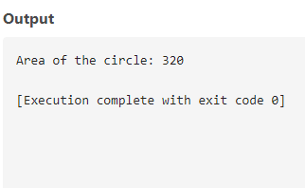

**Multiple Inheristance :-**

**Program :**

class Mathematics {

sub():void {

console.log("Subject")

}

}

class Algebra extends Mathematics {

lin():void {

console.log("Linear Algebra")

}

}

class Geometry extends Algebra{

trig():void {

console.log("Trigonometry")

}

}

let obj = new Geometry();

obj.sub();

obj.lin();

obj.trig();

**Output :**

